Document Management System.

Internationalization and localization

Table of Contents
Introduction 3
Design Consideration 3
Architecture and Benefits. 3
Database Schema 4
User Interface Design: 4
High Level Use case 5

Introduction
DMS software system will provide multi-language support with completely dynamic localization, user not only view the system data in multiple languages but also provide the inputs as per their chosen language.

Design Consideration
Every transactional and metadata table will have main and localized tables. Main table will hold the constant data only. All the transactional fields need to be served form the localized table.
Localized table has all the transaction columns for the respective main table with additional language column. DB System will expose the view for the same which can used for inserting, update and select from the same Every query getting executed on this will append the Company Id, Primary key of main table and language.
Each user has a primary culture assigned by default en_us.
Use can change the culture temporary for this page or control level or default culture.

Architecture and Benefits.
DMS system can provide n number of cultures without any code change only need to add one row in language table.
For every Language, we need to translate the Satellite assembly.
This can be further extended for DMS Culture creation which allow super user to configure the Date format, currency symbol etc.

Database Schema
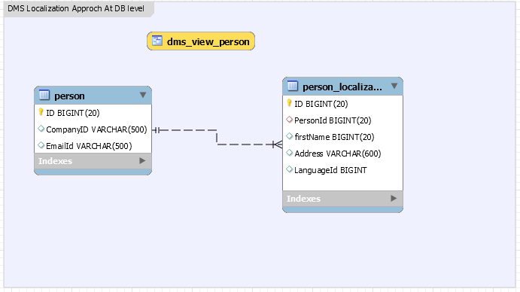
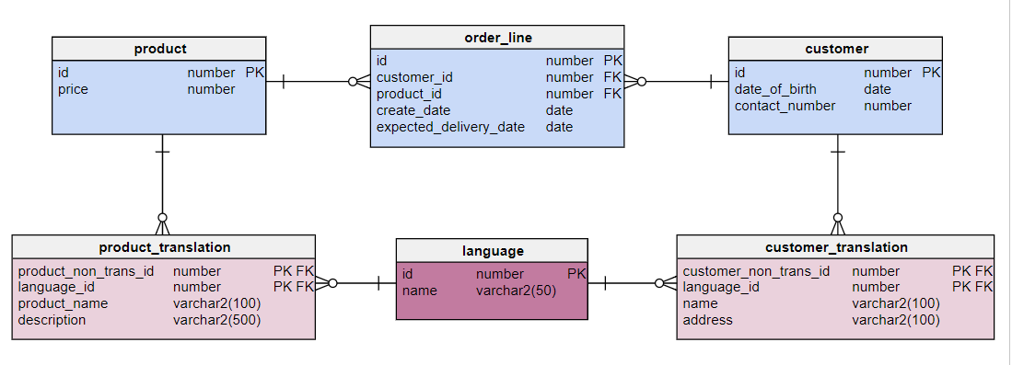

Following View definition for example:
Create view DMS_VIEW_Person as (
select PersonId,CompanyID,EmailId,firstName,Address,LanguageId from Person P INNER JOIN Person_Localization PL ON P.ID =PL.PersonId
)

Localization
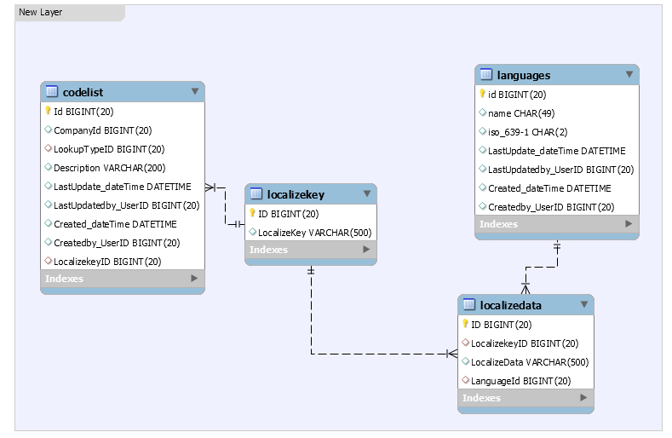
How developer use this localization.

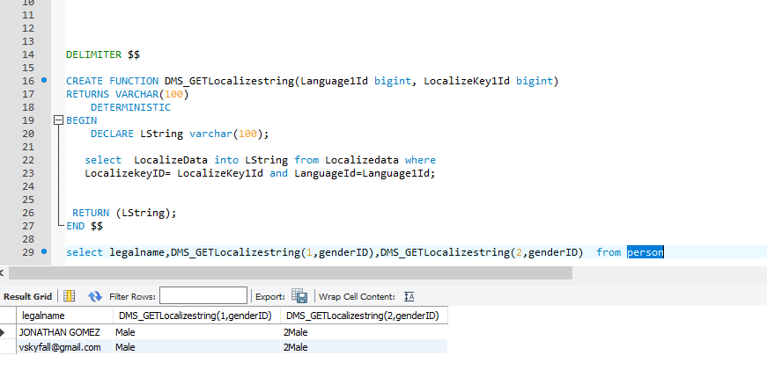

User Interface Design:
On UI, there will be a control where user can change his/her culture and view the page in selected culture.
User can change the default culture.

High Level Use case
DMS User case for localization.
Admin: Build a template with 2 different Localized PDF. Fill the required information on all pages in the send document flow and configure the localized email templates for the send form action.
Performed send action for 100 employees.
End User: User received the email content and PDF link as per their specified culture. May be 20 candidates will get Spanish and 80 employees get English document.
If needed end use can change the culture send
view the other culture PDF.

References:

https://www.vertabelo.com/blog/technical-articles/data-modeling-for-multiple-languages-how-to-design-a-localization-ready-system

select * from codelist;
select * from lookuptype;
select * from Localizekey;
select * from Localizedata

